PA-ETEP Student Learning Objective Training Manual

- When you log in to PA-ETEP, your screen will look like the image below. Click on “begin” under Student Learning Objective.

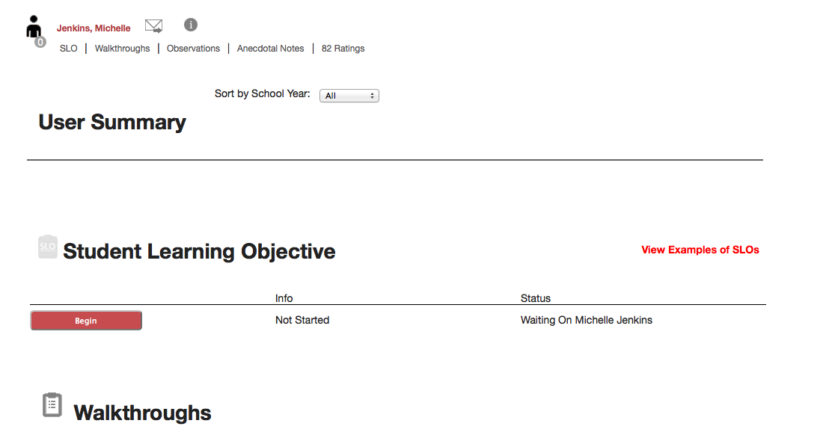

- Section 1: Classroom Context

In this section, you will enter your name and information about the class and course that you will be using as your data set.

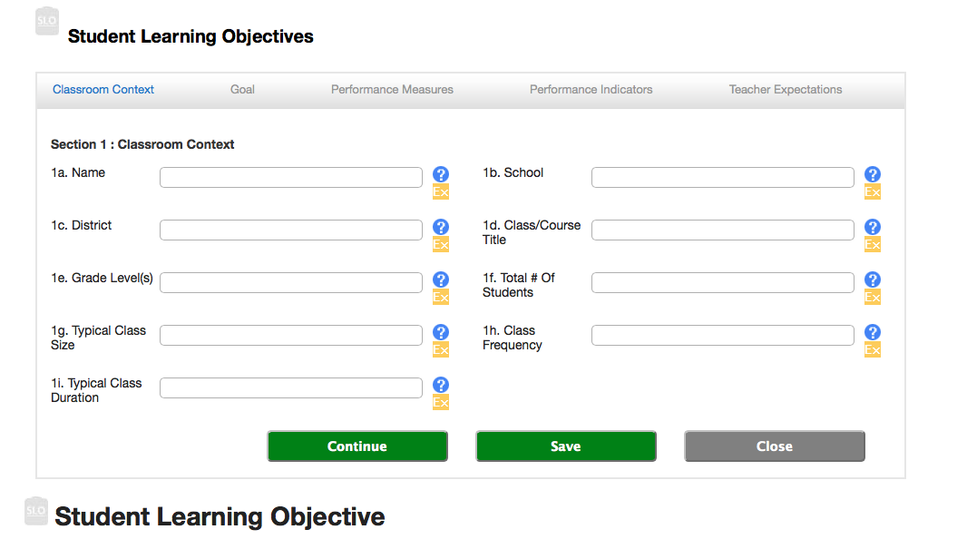

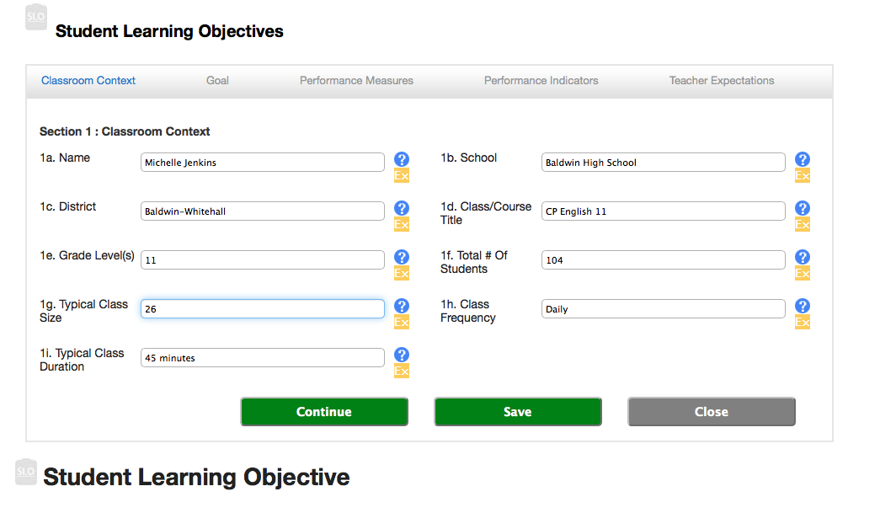
Section 1: Classroom Context Example
- Section 2: Goal

In this section, you will enter your goal statement, PA Standards, and rationale.
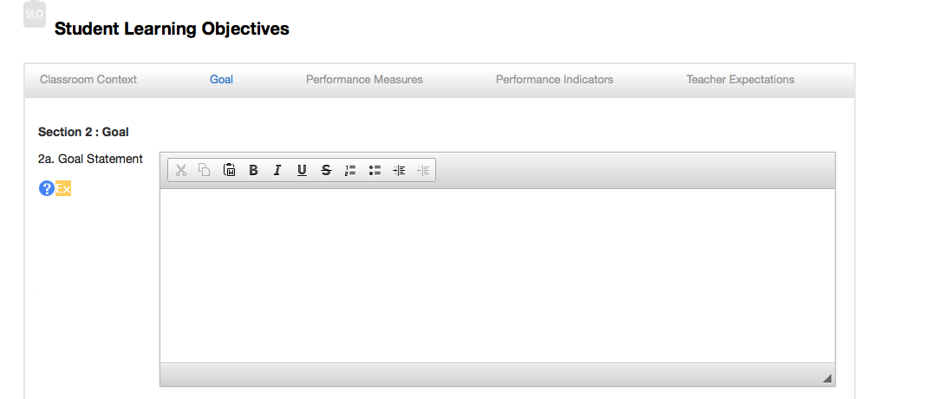

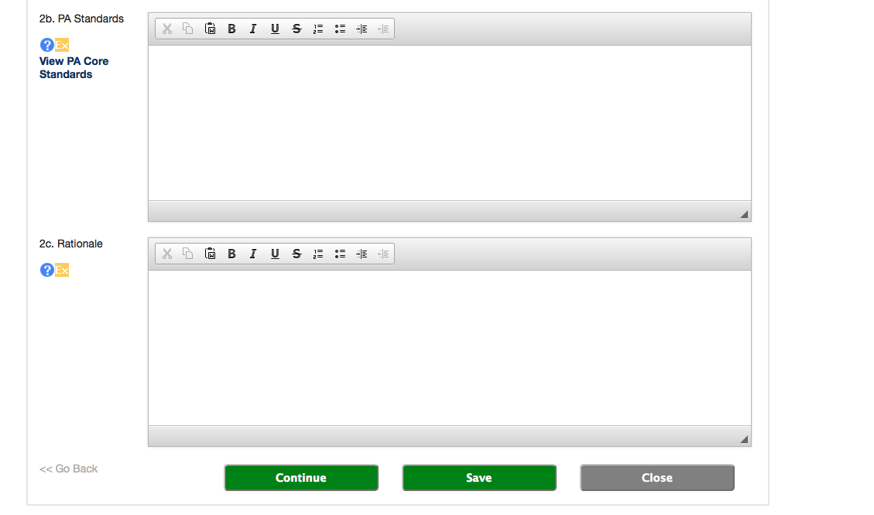
The rationale, composed by the teacher, states why the selected Goal and Standards have been chosen and why they are important for students.
These are the targeted academic standards aligned to the teacher’s Goal Statement.
The Goal Statement is a Big Idea. Big Ideas are declarative statements that transcend grade levels. Big Ideas can be found in the Curriculum Framework on www.pdesas.org or in your district’s written curriculum.

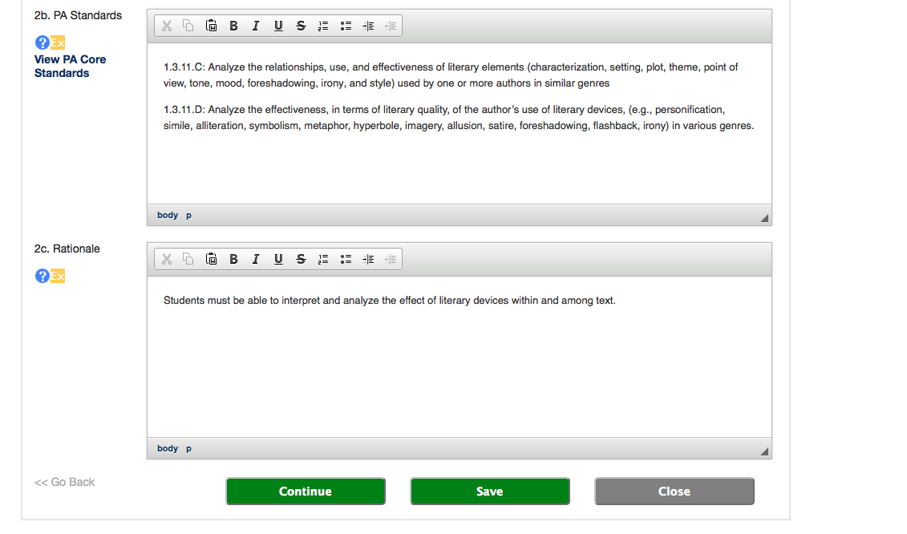
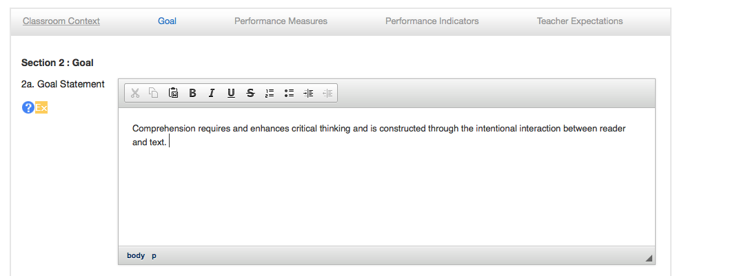
Section 2: Goal Example

- Section 3: Performance Measures

Performance Measures are assessments that will be used to measure the performance indicators.

You must have a minimum of 3 Performance Measures.

Recall, together a pre-test and a post-test constitute 1 Performance Measure.

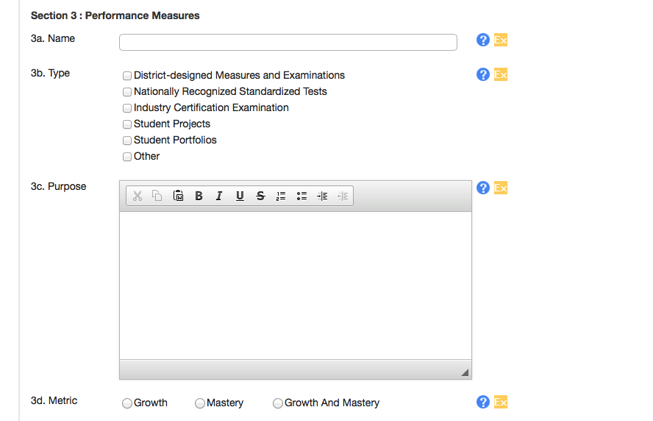
Click + Add Measure

Name of assessment exactly as it appears on assessment.

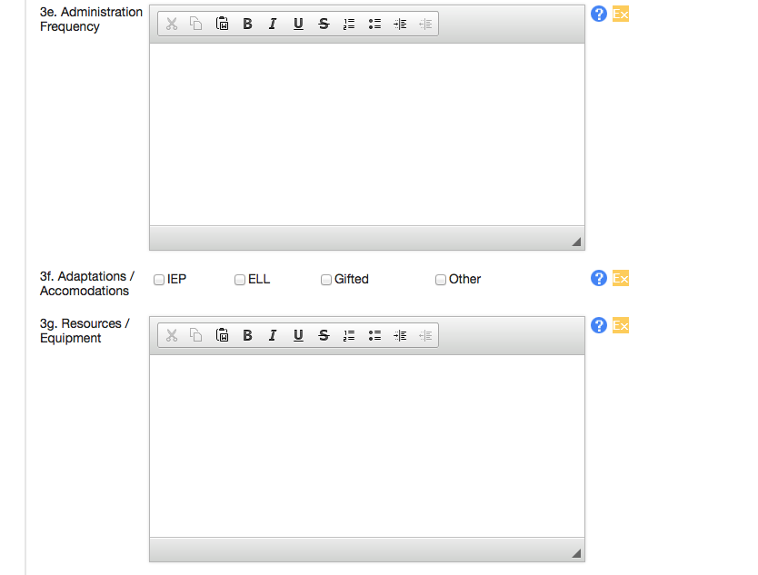
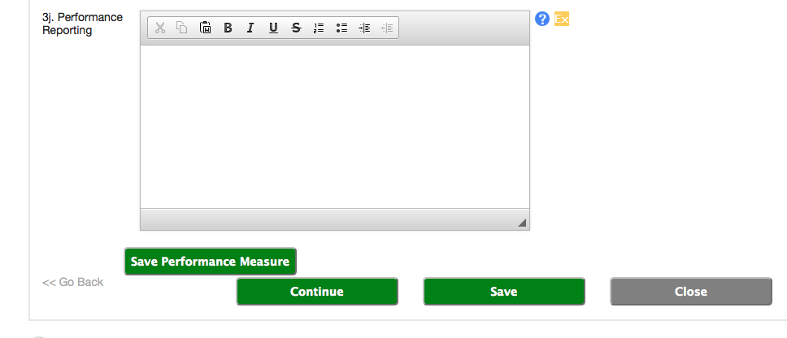
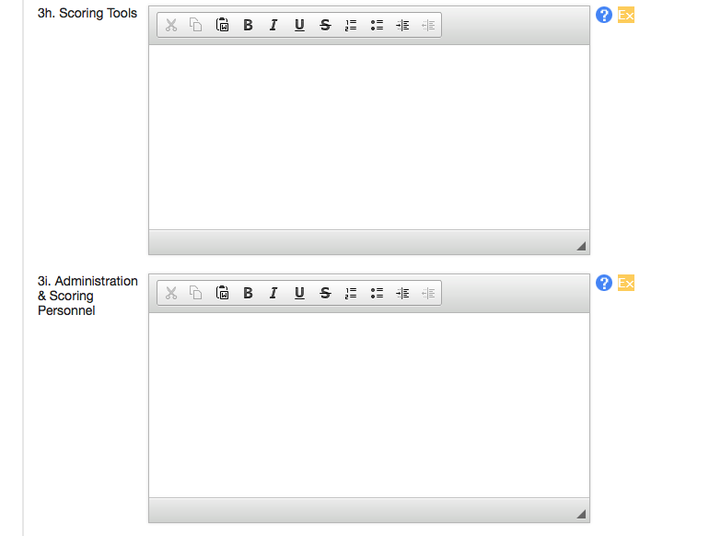
You must use the district designed reporting tool only. (Excel template)

Section 3: Performance Measures Example
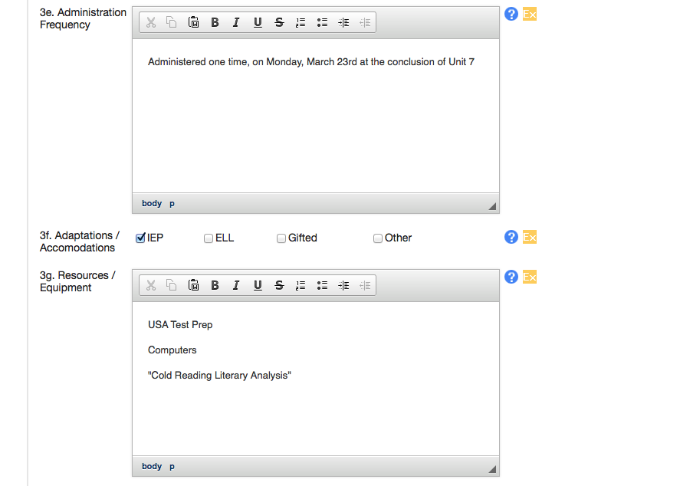
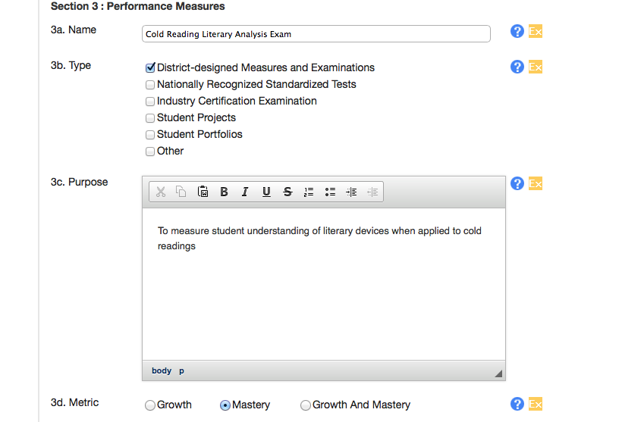

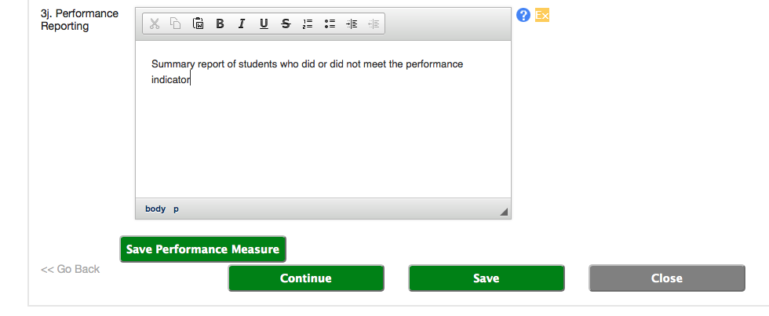
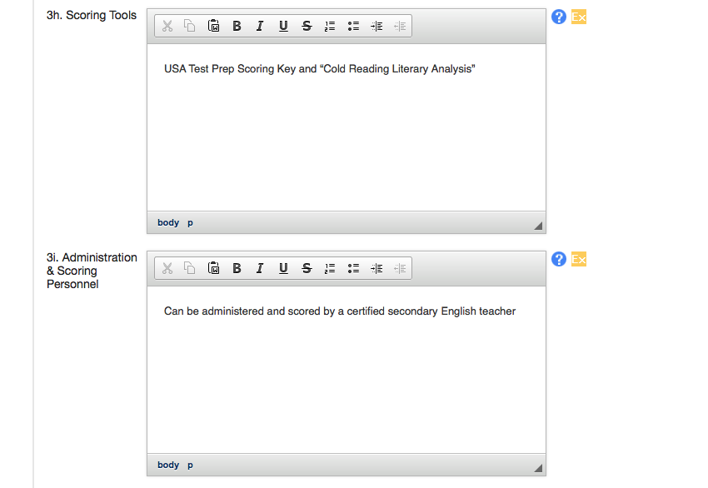
Please see the district designed reporting tool that has already been submitted to you via email.

- Section 4: Performance Indicator

When you click on the fourth section, you will see the name of your assessment.

Click + Add Performance Indicator.

Recall, Performance Indicators are approved ways that the students will demonstrate attaining the teacher goal.

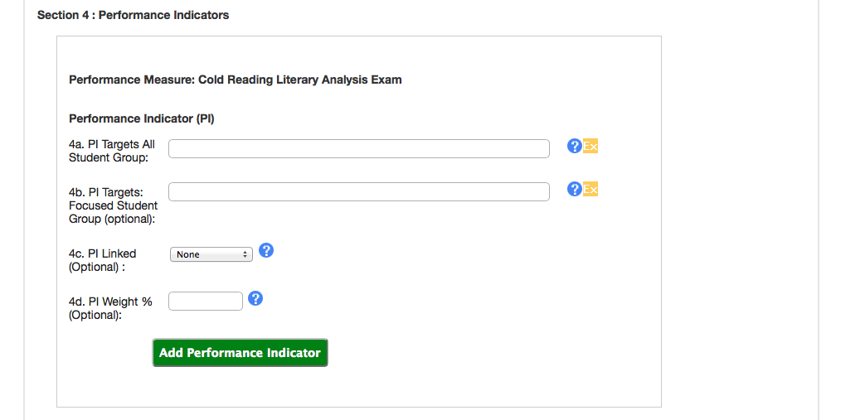
Required A description of the expected level of achievement for each student in the SLO population (as defined by 1f) based on the scoring tool(s) used for each Performance Measure (as listed on 4a).

Optional An assignment of proportional values among Performance Indicators prior to aggregation and application to section 5. Requires use of more than one Performance Indicator.
Optional: Description of any Performance Measure for which a student must meet a specific achievement level in order to meet achievement on additional Performance Measures. Ex: safety test before using tools, a PE skill test before playing a sport.
Optional A description of the expected level of achievement for each student in a subset of the SLO population

Section 4: Performance Indicators

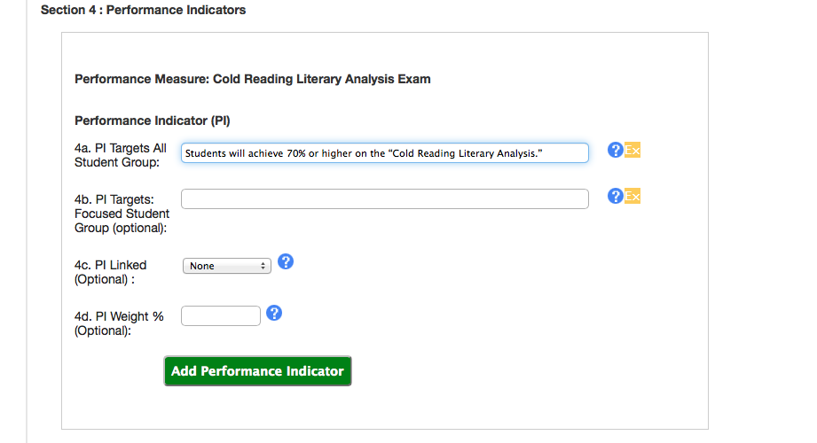

- Section 5: Teacher Expectations
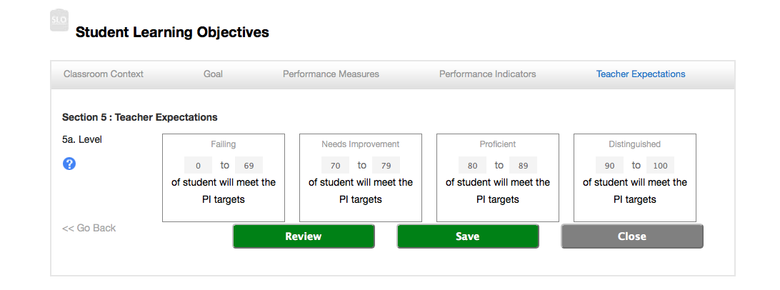
0
599
You must change the ranges in the fields above to reflect the numbers that are below .
100
95
94
70
69
60
You will save and submit once this and all previous steps are completed.

After submitting this to your supervisor, you will administer the assessment(s).
Then, you will go through the following steps on PA-ETEP:

1. Your supervisor can write comments to you before approving.

2. Once your supervisor has approved your SLO, you will have to reply with “Progress Comments.” You specifically have to state the percentage of students who actually reached your “Performance Indicator” in this field and assign yourself your performance ranking based on these results (Failing, Needs Improvement, Proficient, or Distinguished)

3. Your supervisor will review your “Progress Comments” and assign your performance ranking. Your supervisor may also provide you with closing comments.

