Curriculum Mapping Template – File Management

- Go to http://bwsdcurriculum.weebly.com/  - Click on Curriculum Writing Resources | 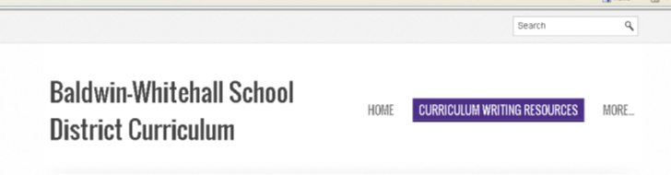
- Click on “Download File” under “BWSD Curriculum Map Template:Unit of Intsruction Overview” | 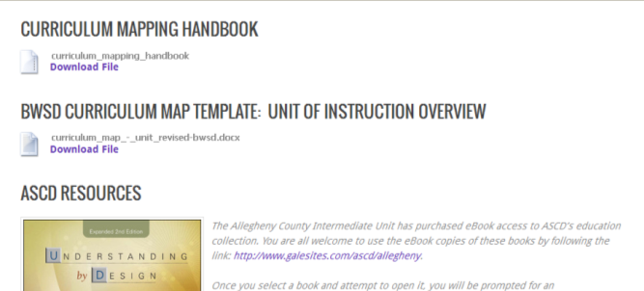
- Click “Save” on the pop-up window | 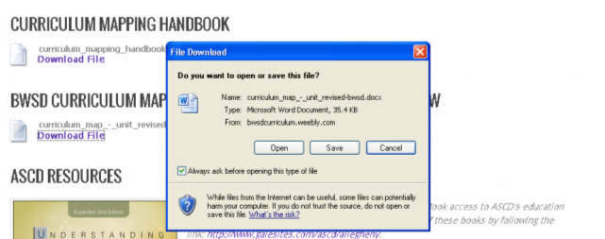
- Select your “H:Drive”  - Title your file by adding your course title to the existing file name  Example:  curriculum_map_-_unit_revised-bwsd-science7 | 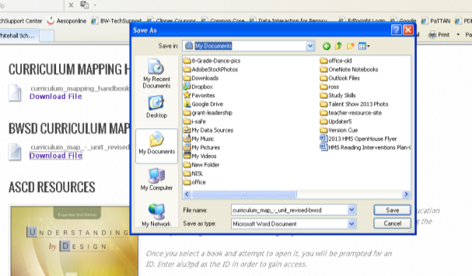
- To open the saved file, navigate to your “H:Drive”
- Select and open the appropriate file
- As you input the information, make sure to save every so often as you complete the template

