Grades 6-12

**PA Core Overview and Transition**

**Baldwin-Whitehall School District**

**Presented by Heather M. Moschetta, Ph.D.**

Reading Achievement Center

Allegheny Intermediate Unit

heather.moschetta@aiu3.net

**Instructional Shift 1:** Regular practice with complex texts and their academic language

**Activity: Analyze your curriculum for text complexity**

**How is the staircase of complexity reflected in in the curriculum and your textbooks?**

* + Passages/literature
  + Instructional learning activities/tasks
  + Assessments of comprehension & analysis

**Notes:** _______________________________________________________________________

___________________________________________________________________________________________________________________________________________________________________________________________________________________________________________________________________________________________________________________________________________________________________________________________________________________________________________________________________________________________________________________________________________________________

**Instructional Shift 1:** Regular practice with complex texts and their academic language

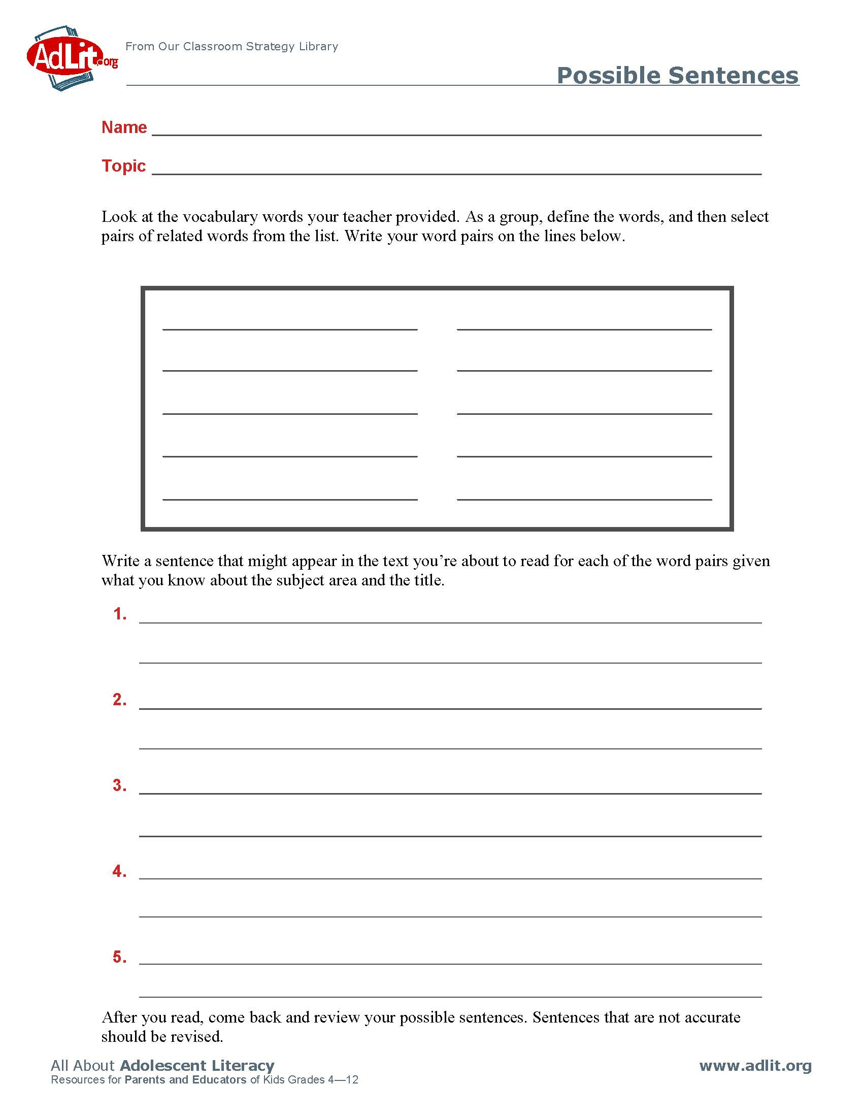**Possible Sentences – Before Reading Activity**

**Instructional Shift 1:** Regular practice with complex texts and their academic language

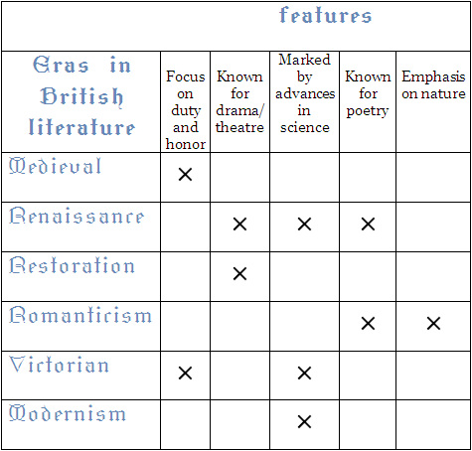**Semantic Feature Mapping – During & After Reading Activity**

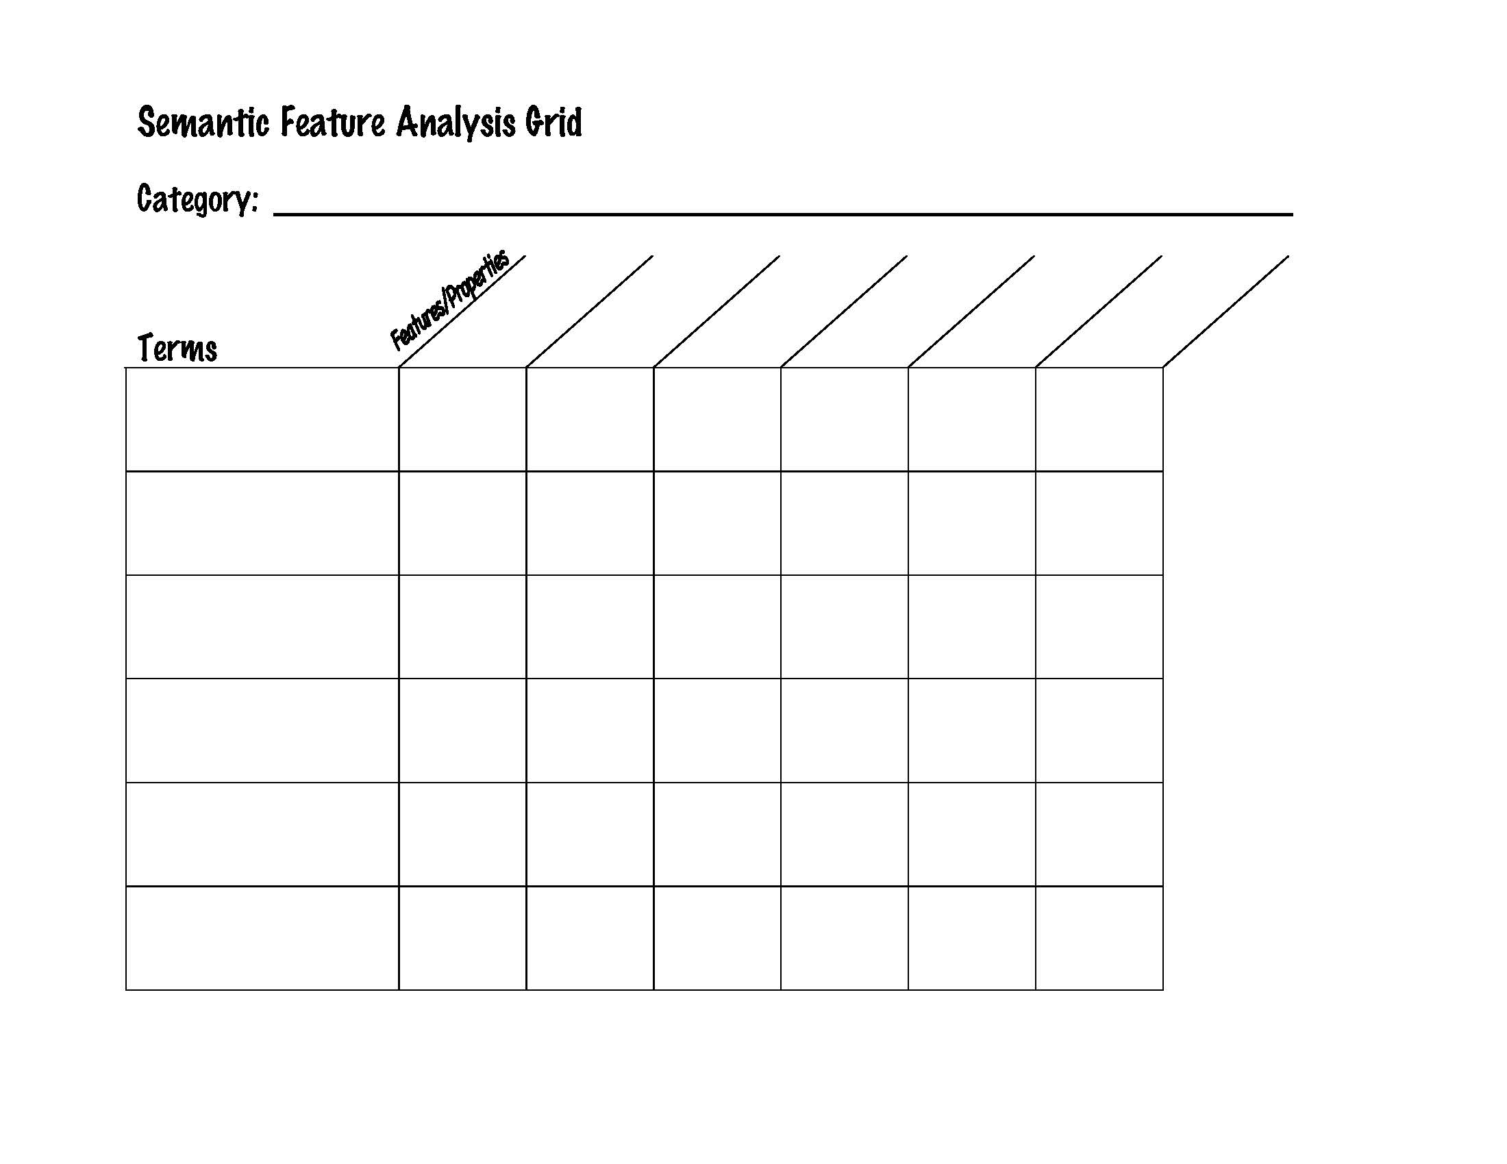

Negative

Condescending

Archaic

Current

Neutral

Positive

**Instructional Shift 1:** Regular practice with complex texts and their academic language

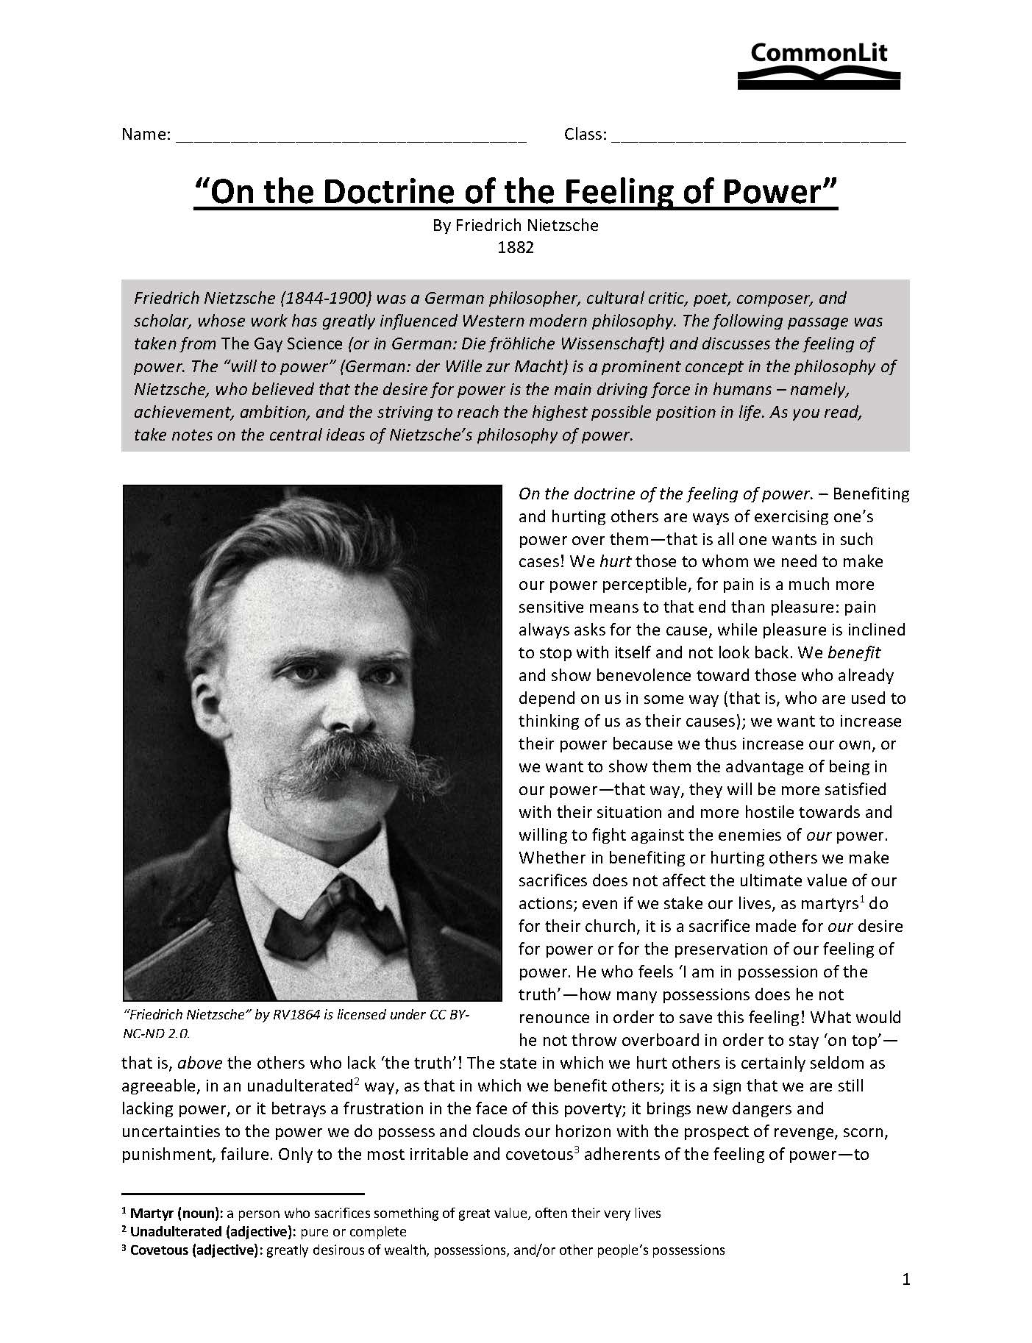

**Instructional Shift 1:** Regular practice with complex texts and their academic language

**Connotation writing activity:**

Write about someone who could be considered “slender.” Be as detailed and descriptive as possible.

Write a minimum of five lines.

Time limit: 1:47

_____________________________________________________________________________

___________________________________________________________________________________________________________________________________________________________________________________________________________________________________________________________________________________________________________________________________________________________________________________________________________________________________________________________________________________________________________________________________________________________

**Instructional Shift 1:** Regular practice with complex texts and their academic language

**Activity: Analyze your curriculum for academic vocabulary**

**How is academic language reflected in in the curriculum and your textbooks?**

* + Passages/literature
  + Vocabulary activities/tasks
  + Vocabulary instruction

**Notes:** ____________________________________________________________________________ ___________________________________________________________________________________________________________________________________________________________________________________________________________________________________________________________________________________________________________________________________________________________________________________________________________________________________________________________________________________________________________________________________________________________

**Instructional Shift 2:** Reading, writing, and speaking grounded in evidence from texts, both literary and informational

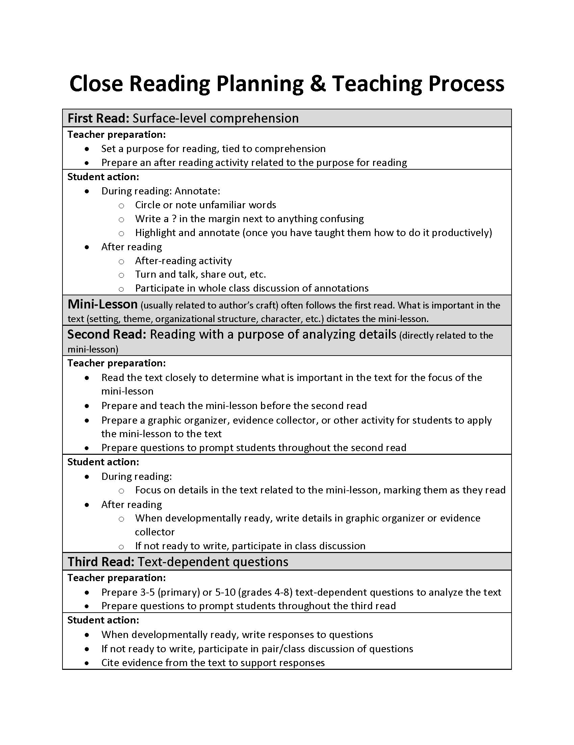

**Please Do Now:** Collins type 1. In a minimum of 8 lines, respond to the following question, making sure to ***explain your reasoning***. Which is more tragic: to die at a young age (under 50) or to live to a very old age (over 80) without having accomplished the goals you set for yourself?

________________________________________________________________________

________________________________________________________________________

________________________________________________________________________

________________________________________________________________________

________________________________________________________________________

________________________________________________________________________

________________________________________________________________________

_______________________________________________________________________■

________________________________________________________________________

________________________________________________________________________

**Turn & Talk.** Read your response verbatim to your learning partner, then listen as your partner reads his or her response to you.

**First Reading:** Read the following short story silently and independently. As you read:

* highlight or underline what stands out to you
* put a question mark near anything that confuses you
* circle any unfamiliar words or terms
* in the margins, write down any comments or questions you have

In the first read, you don’t have to become an expert on every word and every detail; you’re simply getting the gist of the whole story. The first read is the “beach read”; just read for the plot and your general impressions. Later, we’ll look at certain paragraphs or sentences more closely to help us understand certain aspects of the story.

Purpose for reading: Read the short story “Yours” to find out why Robison might have chosen the word ***yours*** as the title.

“Yours” by Mary Robison

Allison struggled away from her white Renault, limping with the weight

1 of the last of the pumpkins. She found Clark in the twilight on the twig- and leaf-littered porch behind the house.

2 He wore a wool shawl. He was moving up and back in a padded glider, pushed by the ball of his slippered foot.

3 Allison lowered a big pumpkin, let it rest on the wide floorboards.

Clark was much older—seventy-eight to Allison’s thirty-five. They were married. They were both quite tall and looked something alike in their facial features. Allison wore a natural-hair wig. It was a thick blonde

4 hood around her face. She was dressed in bright-dyed denims today. She

wore durable clothes, usually, for she volunteered afternoons at a

children’s daycare center.

5 She put one of the smaller pumpkins on Clark’s long lap. “Now, nothing surreal,” she told him. “Carve just a *regular* face. These are for the kids.”

In the foyer, on the Hipplewhite desk, Allison found the maid’s chore list with its cross-offs, which included Clark’s supper. Allison went quickly through the daily mail: a garish coupon packet, a bill from Jamestown Liquors, November’s pay-TV program guide, and the worst thing, the funniest, an already opened,

6 extremely unkind letter from Clark’s relations up North. “You’re an old fool,” Allison read, and, “You’re being cruelly deceived.” There was a gift check for Clark enclosed, but it was uncashable, signed as it was, “Donald Duck.”

Late, late into this night, Allison and Clark gutted and carved the pumpkins together, at an old table set on the back porch, over newspaper after soggy newspaper, with paring knives and with spoons and with a Swiss Army knife Clark used for exact shaping of tooth and eye and nostril. Clark had been a

7 doctor, an internist, but also a Sunday watercolorist. His four pumpkins were expressive and artful. Their carved features were suited to the sizes and shapes of the pumpkins. Two looked ferocious and jagged. One registered surprise. The last was serene and beaming.

Allison’s four faces were less deftly drawn, with slits and areas of

8 distortion. She had cut triangles for noses and eyes. The mouths she had made were just wedges—two turned up and two turned down.

By one in the morning they were finished. Clark, who had bent his long

9 torso forward to work, moved back over to the glider and looked out sleepily at nothing. All the lights were out across the ravine.

Clark stayed. For the season and time, the Virginia night was warm.

10 Most leaves had been blown away already, and the trees stood unbothered. The moon was round above them.

11 Allison cleaned up the mess.

12 “Your jack-o-lanterns are much, much better than mine,” Clark said to her.

13 “Like hell,” Allison said.

14 “Look at me,” Clark said. Allison did.

15 She was holding a squishy bundle of newspapers. The papers reeked sweetly with the smell of pumpkin guts.

16 “Yours are *far* better ,” he said.

17 “You’re wrong. You’ll see when they’re lit,” Allison said.

She went inside and came back with yellow vigil candles. It took her a

18 while to get each candle settled, and then to line up the results in a row on the porch railing. She went along and lit each candle and fixed the pumpkin lids over the little flames.

19 “See?” she said.

20 They sat together a moment and looked at the orange faces.

21 “We’re exhausted. It’s good night time,” Allison said. “Don’t blow out the candles. I’ll put new in tomorrow.”

That night, in their bedroom, a few weeks earlier than had been

22 predicted, Allison began to die. “Don’t look at me if my wig comes off,” she told Clark. “Please.”

Her pulse cords were fluttering under his fingers. She raised her knees

23 and kicked away the comforter. She said something to Clark about the garage being locked.

At the telephone, Clark had a clear view out back and down to the porch. He wanted to laugh with his wife once more. He wanted to tell her, from the greater perspective he had, that to own only a little talent, like

24 his, was an awful, plaguing thing; that being only a little special meant you expected too much, most of the time, and liked yourself too little. He wanted to assure her that she had missed nothing.

25 He was speaking into the phone now. He watched the jack-o-lanterns. The jack-o-lanterns watched him.

**Partner work:** You were directed to read this story to find out why Mary Robison titled the story the way she did. Discuss this with your partner and write down what you think.

***Why do you think Mary Robison called her short story “Yours”?*** *Is the couple having an argument over whose pumpkin is better? (Yours! No, yours!); does one partner belong to the other (I’m yours); is it a closing greeting, like the end of a letter? (Yours truly, so-and-so); is there another reasonable explanation?*

*- - - - - - - - - - - - - - - - - - - - - - - - - - - - - - - - - - - - - - - - - - - - - - - - - - - - - - - - -*

**Class discussion of the soft read.**

**Take notes here:**

**Defining Characterization**

**Characterization** is the process by which the writer reveals the personality of a character. Characterization is revealed through **direct characterization** and **indirect characterization**.

**Direct Characterization** *_______________* the audience what the personality of the character is.

Example: “The patient boy and quiet girl were both well-mannered and did not disobey their mother.”

Explanation: The author is directly telling the audience the personality of these two children. The boy is “patient, obedient and polite” and the girl is “quiet, obedient and well-mannered.”

**Indirect Characterization** *_______________*things that reveal the personality of a character. There are five different methods of indirect characterization:

|  |  |  |
| --- | --- | --- |
| **S** | |  | | --- | | What does the character say? How does the character speak? | |
| **T** | |  | | --- | | What is revealed through the character’s private thoughts and feelings? | |
| **E** | |  | | --- | | What is revealed through the character’s effect on other people? How do other characters feel or behave in reaction to the character? | |
| **A** | |  | | --- | | What does the character do? How does the character behave? | |
| **L** | |  | | --- | | What does the character look like? How does the character dress? | |

C:\WINDOWS\Temp\Temporary Internet Files\Content.IE5\JMFMD05H\MC900445558[1].wmfClark

**Direct characterization**. Mary Robison tells the reader that Clark is…

|  |  |  |
| --- | --- | --- |
| **Character trait** | **Paragraph #** | **Quote** |
|  |  |  |
|  |  |  |
|  |  |  |
|  |  |  |
|  |  |  |
|  |  |  |
|  |  |  |

**Indirect characterization.** Readers can draw inferences about Clark’s personality based on what the writer reveals through speech, thoughts, effect on other characters, actions and looks.

|  |  |  |  |
| --- | --- | --- | --- |
| **Method** | **Paragraph #** | **Character Trait** | **Evidence** |
| What he says |  |  |  |
| What he says |  |  |  |
| What he thinks |  |  |  |
| What he thinks |  |  |  |
| His effect on others |  |  |  |
| His effect on others |  |  |  |
| His actions |  |  |  |
| His actions |  |  |  |
| His looks |  |  |  |
| His looks |  |  |  |

C:\Program Files\Microsoft Office\Media\CntCD1\ClipArt8\j0343545.wmfAllison

**Direct characterization**. Mary Robison tells the reader that Allison is…

|  |  |  |
| --- | --- | --- |
| **Character trait** | **Paragraph #** | **Quote** |
|  |  |  |
|  |  |  |
|  |  |  |
|  |  |  |
|  |  |  |
|  |  |  |
|  |  |  |

**Indirect characterization.** Readers can draw inferences about Allison’s personality based on what the writer reveals through speech, thoughts, effect on other characters, actions and looks.

|  |  |  |  |
| --- | --- | --- | --- |
| **Method** | **Paragraph #** | **Character Trait** | **Evidence** |
| What she says |  |  |  |
| What she says |  |  |  |
| What she thinks |  |  |  |
| What she thinks |  |  |  |
| Her effect on others |  |  |  |
| Her effect on others |  |  |  |
| Her actions |  |  |  |
| Her actions |  |  |  |
| Her looks |  |  |  |
| Her looks |  |  |  |

**Critical Analysis Questions – “Yours” by Mary Robison**

1. In the first sentence, why does Robison use the verb struggle to express Allison’s getting out of her car?

2. What do readers know of the setting from just the first paragraph? Why does setting the story in the fall add a layer of meaning to the story?

3. In paragraph 4, Robison points out that Allison wears durable clothes because she volunteered at a daycare center. What else does the reader learn about Allison from this detail? Are there other details in the story that support this inference?

4. In paragraph 5, Allison warns Clark not to make any of the pumpkins surreal. If you describe something as surreal, you mean that the elements in it are combined in a strange way that you would not normally expect, like in a dream. How does the prefix sur- (which is related to sub-) help you understand this?

5. In paragraph 6, why does Allison think the unkind letter from Clark’s family is the funniest thing in the day’s mail?

6. Why does the story begin and end with pumpkins? How are the pumpkins transformed from the beginning of the story to the end? What do the four faces carved by Clark suggest? What about the two opposing faces carved by Allison?

7. Reread the dialogue from paragraphs 12-16. Why do you think Clark repeats himself, insisting that Allison’s pumpkins are better? Is this kind of lie forgivable? Explain why or why not.

8. Allison and Clark are of vastly different ages. When you first read of their age difference, what did you expect to happen in the story? Why did you think they were together? How does our culture fell about couples with such an age difference? By the end of the story, how do their ages work differently than you perhaps expected?

9. Reread paragraph 24. Compare it to your response from the Please Do Now prompt on day 1. To what degree do you agree with Clark?

10. Why does a narrator (and not one of the characters) tell the story? How would the story be different if told from Clark’s point of view? Allison’s point of view?

**TDA (text dependent analysis)** Writers use a variety of methods to reveal the personalities of their characters. Analyze how Mary Robison creates a sympathetic character in Allison or Clark (choose only one) in her short story “Yours.” Be sure to name the characterization method(s) and cite evidence from the text to support your claim.

_____________________________________________________________________________________

_____________________________________________________________________________________

_____________________________________________________________________________________

_____________________________________________________________________________________

_____________________________________________________________________________________

_____________________________________________________________________________________

_____________________________________________________________________________________

_____________________________________________________________________________________

_____________________________________________________________________________________

_____________________________________________________________________________________

_____________________________________________________________________________________

_____________________________________________________________________________________

_____________________________________________________________________________________

_____________________________________________________________________________________

_____________________________________________________________________________________

_____________________________________________________________________________________

_____________________________________________________________________________________

_____________________________________________________________________________________

_____________________________________________________________________________________

_____________________________________________________________________________________

_____________________________________________________________________________________

_____________________________________________________________________________________

_____________________________________________________________________________________

_____________________________________________________________________________________

_____________________________________________________________________________________

_____________________________________________________________________________________

_____________________________________________________________________________________

_____________________________________________________________________________________

_____________________________________________________________________________________

__________________________________________________________________________________________________________________________________________________________________________

_____________________________________________________________________________________

_____________________________________________________________________________________

_____________________________________________________________________________________

_____________________________________________________________________________________

_____________________________________________________________________________________

__________________________________________________________________________________________________________________________________________________________________________

_____________________________________________________________________________________

_____________________________________________________________________________________

_____________________________________________________________________________________

**Instructional Shift 2:** Reading, writing, and speaking grounded in evidence from texts, both literary and informational

**Activity: Analyze your curriculum for text evidence**

**How is text evidence reflected in in the curriculum and your textbooks?**

* + Close reading
  + Text-dependent questions
  + Analysis questions
  + Questions and texts that require deep inferencing
  + Writing activities/assignments requiring students to cite evidence

**Notes:** _______________________________________________________________________

___________________________________________________________________________________________________________________________________________________________________________________________________________________________________________________________________________________________________________________________________________________________________________________________________________________________________________________________________________________________________________________________________________________________

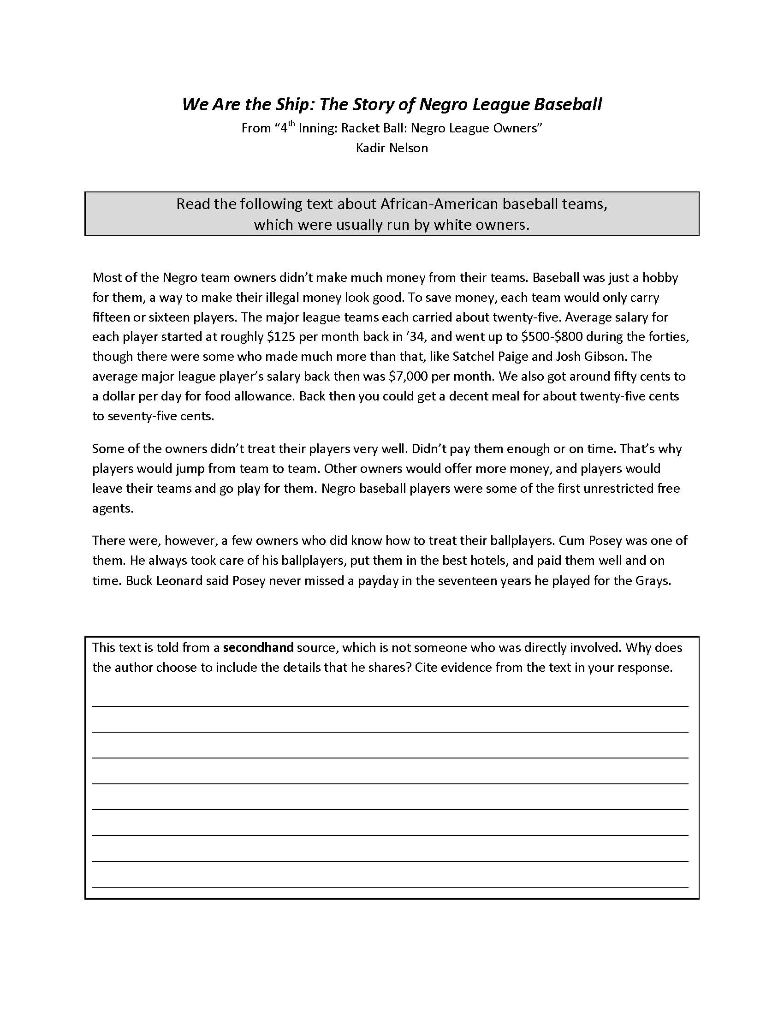**Instructional Shift 3:** Building knowledge through content-rich nonfiction

Details that should be included in a proficient/advanced response:

* Students should **draw the conclusion** that by sharing challenges faced by Negro ballplayers, the author is trying to get the reader to empathize with the Negro players.
* Comparing the salaries of the major league players with the salaries of Negro league players emphasizes the huge divide between white and black during this time period, not just for baseball players but for society in general.
* The sentence “Negro baseball players were some of the first unrestricted free agents” is included to show that black players did not simply accept their circumstances. It also shows that they were ahead of their time in some ways.
* The last paragraph is included to stress that not all white owners treated their black players poorly.

**Activity: Analyze Your Curriculum for Content-Rich Nonfiction**

**How is knowledge building though content-rich nonfiction reflected in in the curriculum and your textbooks?**

* + Genre-based units or text pairings/text sets?
  + 50/50 balance (grades 3-5)
  + Amount of literary nonfiction (grade 6)
  + How much is **student-directed** (vs. teacher-directed) learning?

**Notes:** _______________________________________________________________________ ___________________________________________________________________________________________________________________________________________________________________________________________________________________________________________________________________________________________________________________________________________________________________________________________________________________________________________________________________________________________________________________________________________________________